|  |  |  |
| --- | --- | --- |
| Project Settings: <https://drive.google.com/open?id=1bIWSzxDlhNRyUOUX_9wq728ZlzKtD0T2mv1hEl6MYnA>  Please view project settings before start | | |

1. **Task Requirement / Description**
2. **Navigate to Task Area**
3. **UI Example**
4. **Programming Logic**
5. **Database**
6. **Changes to Commit ( developer to complete )**
   1. **Files / Folders to add to live site**
   2. **Database Changes to add to live site**
   3. **Developer notes / instructions for Project Manager**

**1. Task Requirement / Description**

The product page has a youtube video on bottome of the page. The customer would like to be able to change the video to one of their choice.

Please add a page in the admin “Product Page Video” and add a text box in the page where the customer can paste the youtube embedded movie link and save.

After save show the movie in the admin “Product Page Video” page and also the product page in the live site

Save string into a new table called “product_video” with fields videoID and videoLink

When user saves a value delete all records in the table before insert so then there is only ever one record.

**2. Navigate to Task Area**



**3. UI Example**

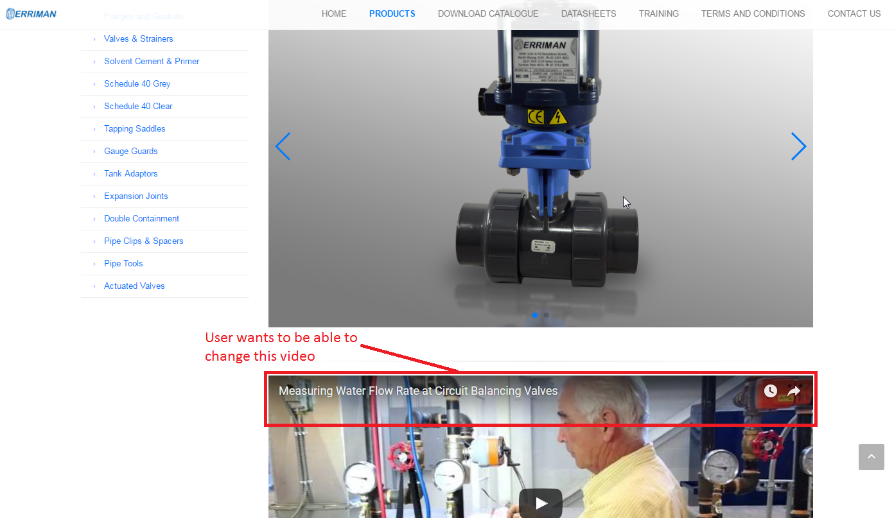

**4. Programming Logic**

When page loads check if a record exists, if exists then show youtube video.

**5. Database**

Create new table:

Product_video

* videoID int auto increament
* videoLink varcahr(255)

DROP TABLE IF EXISTS `merriman`.`product_video`;

CREATE TABLE `merriman`.`product_video` (

`id` bigint(20) unsigned NOT NULL AUTO_INCREMENT,

`url` varchar(255) NOT NULL,

PRIMARY KEY (`id`)

) ENGINE=InnoDB AUTO_INCREMENT=6 DEFAULT CHARSET=latin1;

**6. Changes to Commit ( Developer to Complete section 6a, 6b, 6c)**

This section is to help the Project Manager update the test site and live site. Please fill in the below area’s 6a, 6b and 6c, this is to inform the Project Manager as to what changes were made and needed to add update the live site

**6a. Files / Folders to add to live site**

Please add to the below table a list of files or folders that the Project Manager will need to upload to the live site.

|  |  |  |  |
| --- | --- | --- | --- |
| Folder Name: |  | | |
| File Name | File Name | File Name | File Name |
|  |  |  |  |
|  |  |  |  |
|  |  |  |  |

|  |  |  |  |
| --- | --- | --- | --- |
| Folder Name: |  | | |
| File Name | File Name | File Name | File Name |
|  |  |  |  |
|  |  |  |  |
|  |  |  |  |

|  |  |  |  |
| --- | --- | --- | --- |
| Folder Name: |  | | |
| File Name | File Name | File Name | File Name |
|  |  |  |  |
|  |  |  |  |
|  |  |  |  |

**6b. Database Changes to add to live site**

Please add below any db changes or db script code the Project Manager will need to add to the live site database

**6c. Developer notes / instructions for Project Manager**

Please add here any instructions for the Project Manager to follow for updating the live site

Eg. 1. Please run db script

2. Please insert new data to db

3. Then update files in live site

**END**